C Language
________________________________________________________________________________
Q. what is c language?
________________________________________________________________________
C is high level programming language

Q. what is programming?
________________________________________________________________
Programming means logical thinking of person called as programming which is used for achieve specified task called as programming.

Now we want to start programming with c language then we should have to know

How to create application in C Language
__________________________________________________________________________
if we want to create application in c language have some important points.

1. Download the Turboc++ as editor
____________________________________________________________________________
Q. what is turboc++?
turboc++ is edtor which provide environment to us to create and execute c program.

2. Create Sample application
_____________________________________________________________
If we want to create any program in c language we have to know some important points.
a) Add header file in code.
Q. What is header file?
_________________________________________________________________________
Header file is collection of functions in c language

Q. what is function?
_______________________________________________________
Function is a statement which is used for writing some logics

If we want to work with c program we required to two add minimum two header files.

stdio.h : standard input and output header file.
conio.h: console input and output header file
if we want to add any header file in program we have to use #include
Syntax: #include<filename.h>
Example: #include<stdio.h>
#include<conio.h>

b) Write main function and logic
___________________________________________________________________
Q. what Is main function?
____________________________________________________________
Main function is heart of c language means without main function you cannot run or execute c program.

How to write main function
_________________________________________________________________
void main(){
write here your logics
}
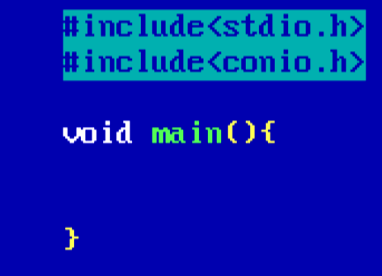
Generalize format of c program.

Example: we want to design program to display the good morning message on output screen.
if we want to show the anything on program output screen we have to use printf() function
and this function is member of stdio.h header means if we want to use this function you must be add stdio.h header file in program before main

Syntax: printf(“message”);

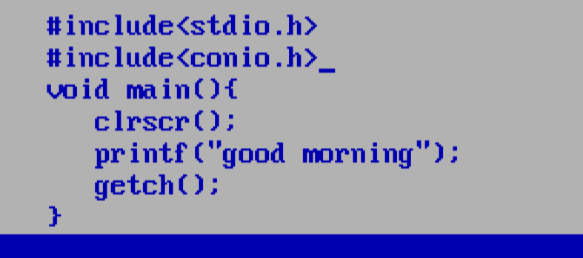

3. Save the application
4. Compile and run the application

Data Type in c Language
___________________________________________________________________

Q. what is data type?
____________________________________________________________________
Data type means to decide what kind of information we want to use in program called as data type.

There are three types of data type in c Language
____________________________________________________________________________
a) Built in Data type: built in data type means those data type already present in c language called as build in data type.
There are three types of built in data type?
_____________________________________________________________________________
a) Integer: it is used for store the non decimal point values
There are four types of integer
___________________________________________________________
i) Integer
How to use in program: int
Memory required : 2 byte

Q. why 2 byte?
________________________________________________
it is not a fix it is depend compiler
means suppose if we work TCC then it required 2 byte and if we work with GCC and JIt it required 4 byte of memory

Can we see the memory size of data type?
________________________________________________________________
if we want to see the size of data type we required to use sizeof() operator

Syntax: sizeof(datatype);

Range: range means calculation capacity of data type or value storing capacity of data type.
-32768 to 32767 range is always is dependent on memory size of datatype

Format specifier: when we use data type in printf() and in scanf() then we can use format specifier
if we use the integer data type then your format specifier is %d
ii) long integer :
how to use in program: long int
Memory Required: 4 byte
Format specifier: %ld
Range:
31
2 = -2147483648 to 2147483647
Format specifier: %ld

iii) Unsigned integer
How to use in program: unsigned int
Memory required: 2 byte
Range: 0 to 65535
Format specifier: %u
iv) Short integer
_______________________________________________________________________
How to use in Program: short int
Memory required: 2 byte
Range: -32768 to 32767
Format specifier: %i or %d

b) Float
____________________________________________________________________________
Floating data type help us to store decimal point values.

There are three types of float data type
_____________________________________________________________________________
i) float :
How to use in program: float
Memory required: 4 byte
Range: 38 38
-3.14 x 10 to 3.14 x 10
Format specifier: %f

ii) Double:
How to use in program: double
Memory Required: 8 byte
Format Specifier: %lf
Range: 308 308
-1.7 x 10 to 1.7 x 10

iii) long double
How to use in program: long double
Memory Required : 10 byte
Range: 4932 4932
-1.7 x 10 to 1.7 x 10
Format specifier :%Lf

c) Character:
Character data type is used for store alpha numeric values.

There are two types of character data type
__________________________________________________________________________________

i) Sign char
How to use in program: char
Memory required: 1 byte
Range: -128 to 127
Format specifier: %c

ii) Unsigned char
How to use in program: unsigned char
Memory required: 1 byte
Range: 0 to 255
Format specifier: %c

b) User Defined Data Type: user defined data type means those data type already define by user for its own use called as user defined data type.
a) structure
b) union
c) enum

c) Derived Data type : those data type acquire the property from another data type and complete its own meaning called as derived data type.
a) pointer
b) function
c) array

Operator
___________________________________________________________________
Operator is the some symbols to perform some operations.

There are seven types of operator
________________________________________________________________________

1. Arithmetic: arithmetic operator means to perform arithmetic operations.
Operator | Meaning
+ | Addition
- | Substrcation
* | Multiplication
/ | Division
% | Reminder or modulas
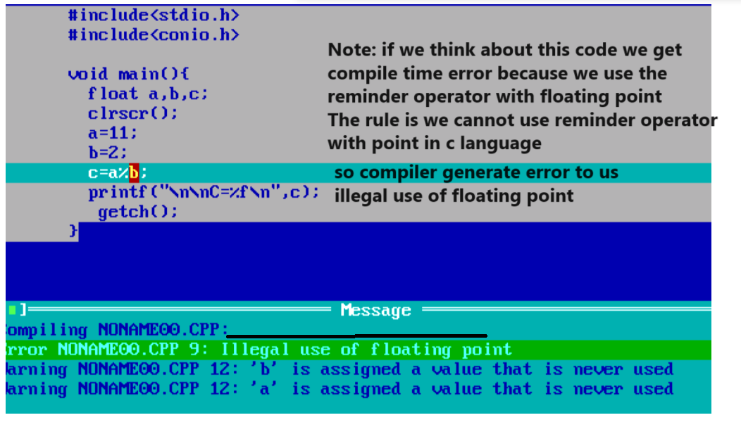

How to calculate the reminder of floating value
______________________________________________________________________________
If we want to calculate reminder of floating value we have two ways

a) Use fmod() function from math.h header file
___________________________________________________________________
fmod() is a function from math.h header file which is used for calculate the reminder of floating value means if we want to use fmod() we required to add the math.h header file in program.
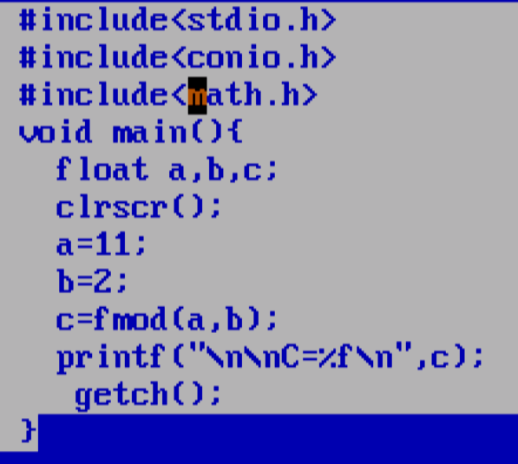
Output:
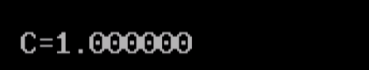
b) Use type casting technique:
Q. what is type casting?
______________________________________________________________________
Type casting means if we convert one type of data in to another type for single line of code called as type casting
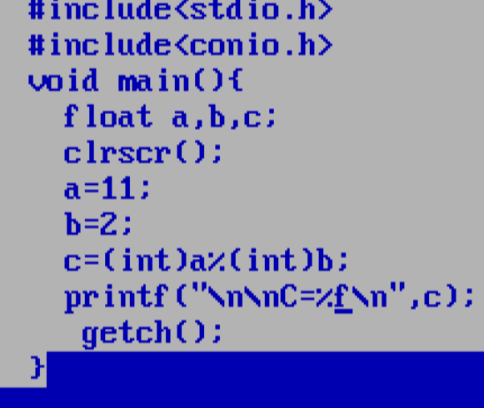
Output

2. Assignment: assignment operator is used for assign right hand value in to left hand variable called as assignment operator.
Operator | Meaning
= | Assign

3. Relational: relational operator is used for perform comparison when comparison gets success return 1 otherwise return 0. In the case of c language 1 means true and 0 means false.

Operator | Meaning
> | Greater than
< | Less than
== | Equal to
!= | Not equal
<= | Less than equal to
>= | Greater than equal to
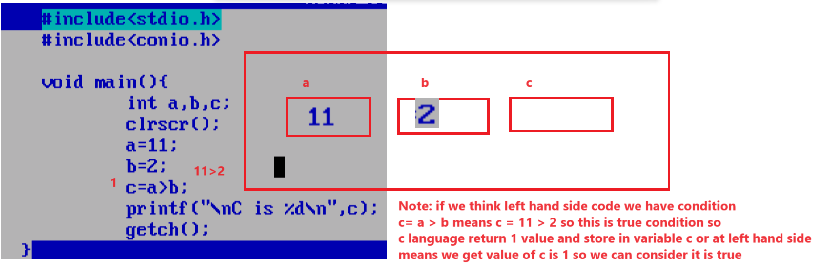
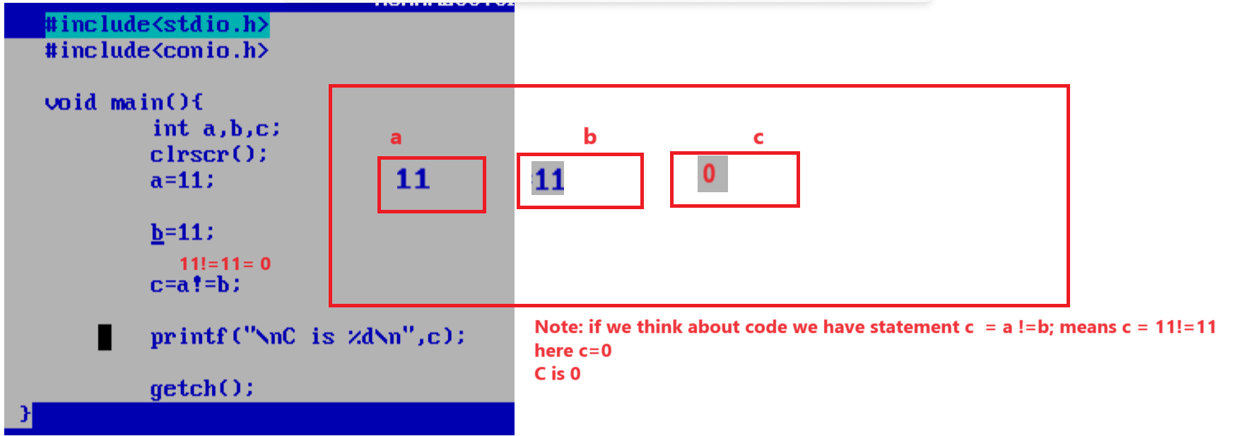

4. Logical: Logical operator is used for combine more than one condition and check it called as logical operator.
Operator | Meaning
&& | Logical AND if all conditions are true then condition is true otherwise false
|| | Logical OR if any one condition is true then condition is true if all conditions are false then condition false
! | Logical NOT if true then false and if false then true

Note: every logical operator is internally logical Gate means every condition with logical operator considers as input to logical gate and result of condition is 1 or 0 so it is input value to logical age shown in following example.
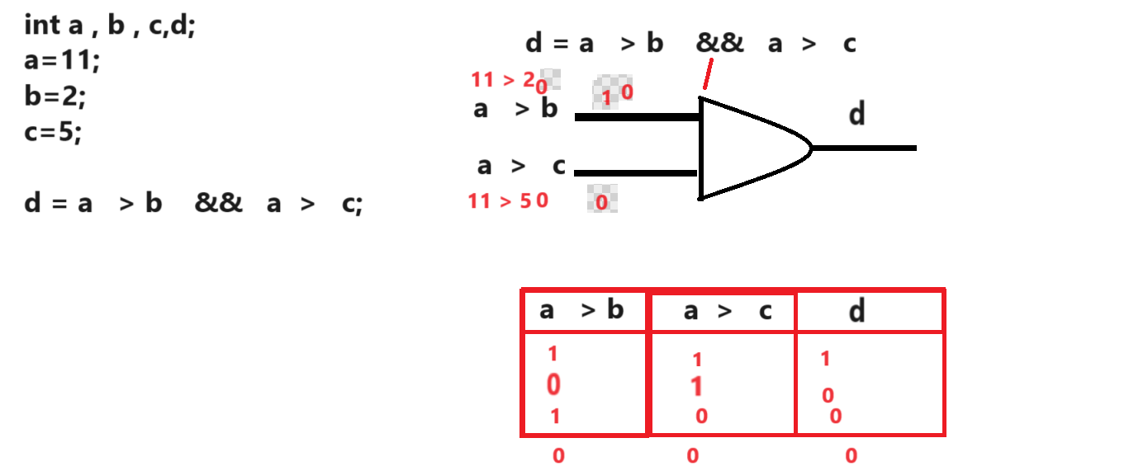
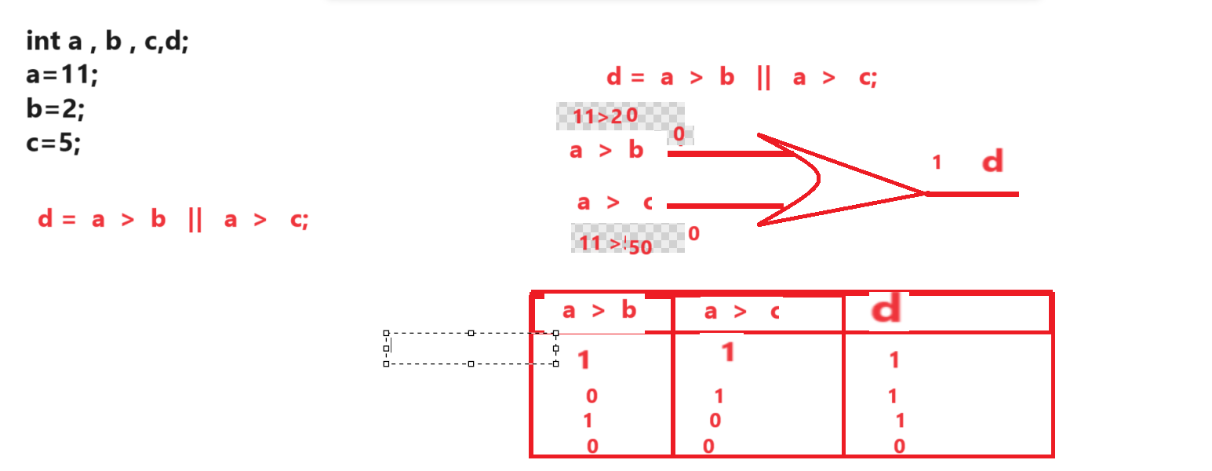

Example of logical NOT
_____________________________________________________________________________
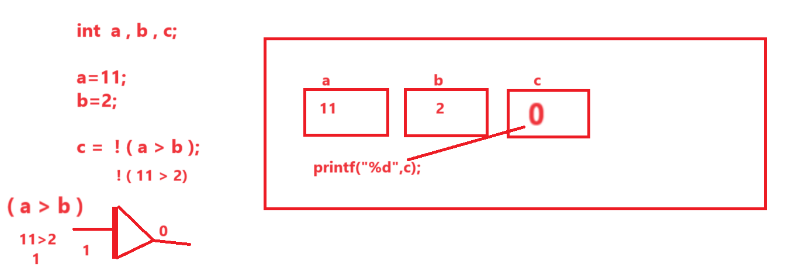

5. Increment and Decrement: increment and decrement operator is used for increase value by 1 and decrease value by 1

Operator | Meaning
++ | Increase by 1
-- | Decrease by 1

There are two types of increment and decrement operator
_________________________________________________________________________
Pre increment and pre decrement: In the case of pre increment first we perform operation using operator and then we can shift at left hand side.

Syntax: variablename op;
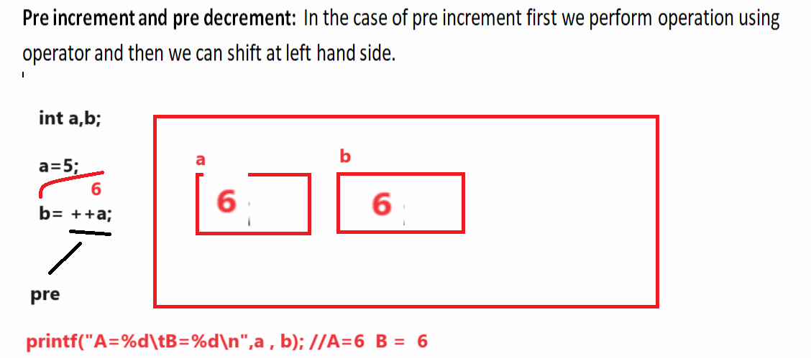
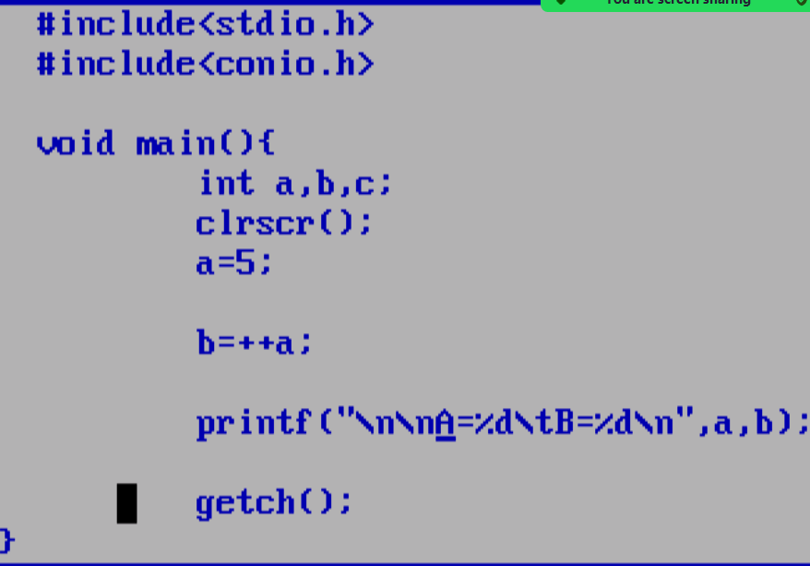

Post decrement and Post increment: In the case of post increment or post decrement first we shift value at left hand side and after that performs operation using operator.

Syntax variable op;
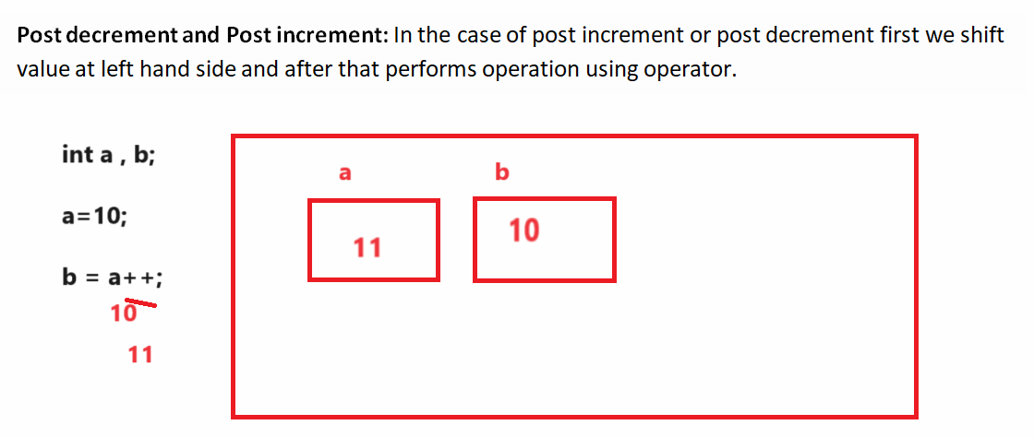

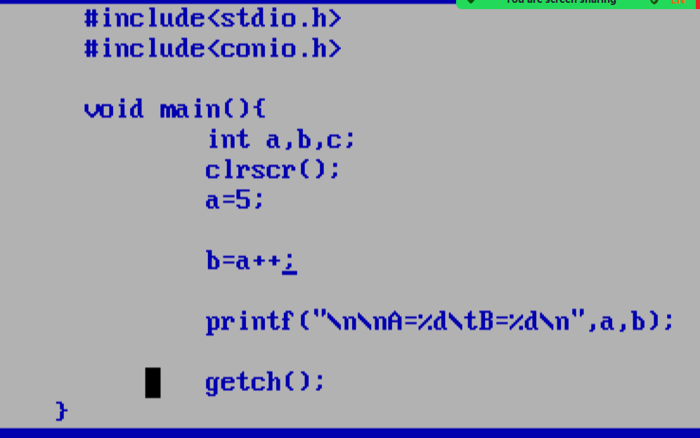

6. Conditional
_____________________________________________________________________________
Conditional operator is used for check the conditions
Operator | Meaning
? | Ternary operator
: | Colon operator

Generalize format of Conditional operator
_____________________________________________________________________________
Syntax: exp1 ? exp2 : exp3;

exp1 is always condition and exp2 and exp3 are the options if exp1 is true then exp2 get executed and if exp1 is false then exp3 get executed.

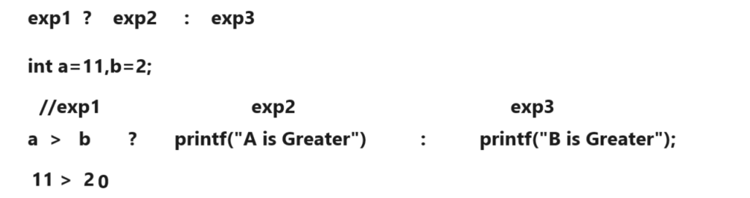
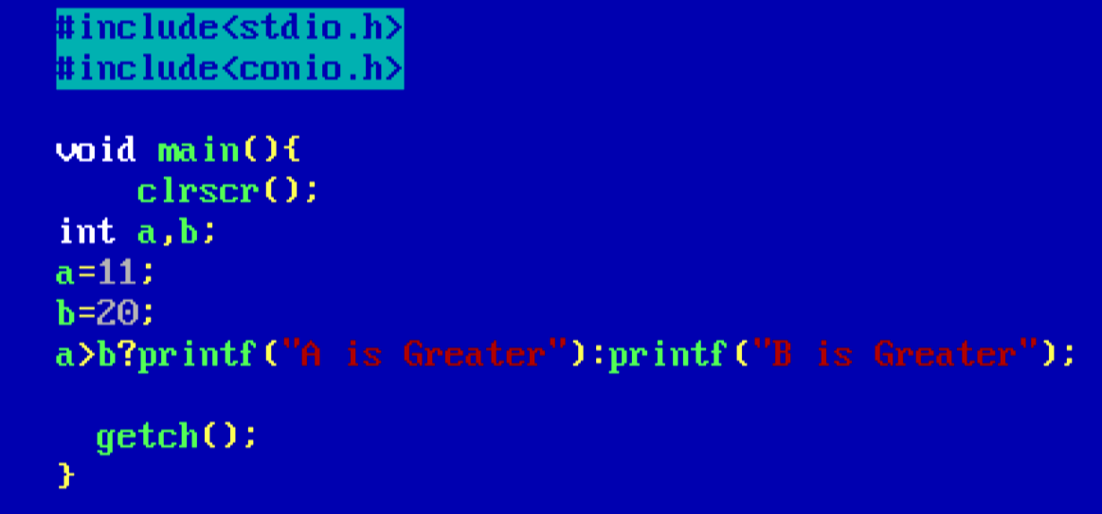

Variable and Constant in C Language
__________________________________________________________________________________

Q. what is variable?
__________________________________________________________________________
Variable is block of memory where we can store data in it as per their data type.

How to declare variable in C Language
____________________________________________________________________________________
Syntax: datatype variablename;
Example: int a;
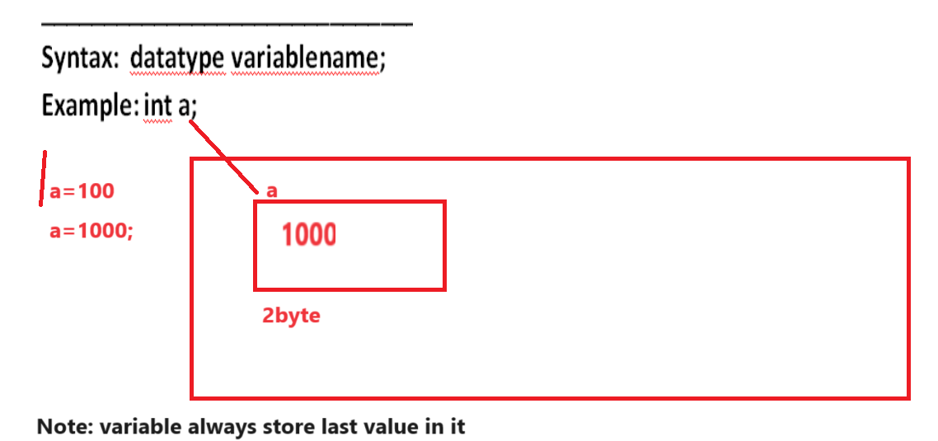
If we want to declare variable in c language we have some important points.

a) variable name start with alphabet or underscore character
Example: int abbc, int _abc;
b) Variable name cannot start with digit but digit may be come later in variable name
int a10; //valid
int 10a;//invalid
c) Cannot use any special symbol in variable name except underscore
int a?b;//invalid variable name
int a_b;//valid variable name
d) small variable name and capital variable name consider different.
int a,A;//these are the different variable name;

Constant in C Language
________________________________________________________________________
Constant means those value never change in program called as constant

Q. Why use Constant or what is benefit of constant?
______________________________________________________________________________
Reusability is major benefit of constant suppose some if we required some value multiple time then writing same value multiple time is not good approach and not feasible in real time so better way you can fix the value at some place and you can reuse it multiple

Example: suppose consider we have value 123456789123 and we want to use this value 100 place in code so we need to write this value 100 times and suppose someone ask you change the value from 123456789123 to 678678 then we need to perform change at 100 place it is not possible in real time so best you can fix the value a=123456789123 and you can use a 100 times so we use value 100 time through the a and if we want to modify the value then we need to modify at one place

Types of constant in C Language
________________________________________________________________________

a) Numeric Constant: Numeric constant means where we can set number as constant value.
Types of numeric constant
______________________________________________________________
i) Integer constant: Integer constant means those constant not store floating point value in it called as integer constant.
Example: 12345, 678, 987 etc
ii) Float Constant: float constant means those constant contain value with floating point called as float constant
Example: 5.4,2.5 , 3.5 etc

iii) Octal Constant: if we use any value between 0 to 7 and preceding with 0 called as octal constant
Example: 072 //octal constant
0123//octal constant
iv) Hexa Decimal Constant : Hexa Decimal Constant means those constant contain value between 0 to 15 and start with 0x called as hexa decimal constant.
Example: 0x123 or 0X123

b) Character Constant: Character constant means those constant contain alpha numeric value called as character constant.

There are two types of character constant
___________________________________________________________________
a) Single character constant: if we use any value within single quote called as single character constant.
Example: ‘a’, ‘b’,’c’,’5’ etc it is your single character constant.

b) String constant: String constant means those value present between double quote called as string constant.
“abc”, “mno” etc

7. Bitwise : we will see after two days

Example: WAP to declare two variable name as a and b and calculate its addition.
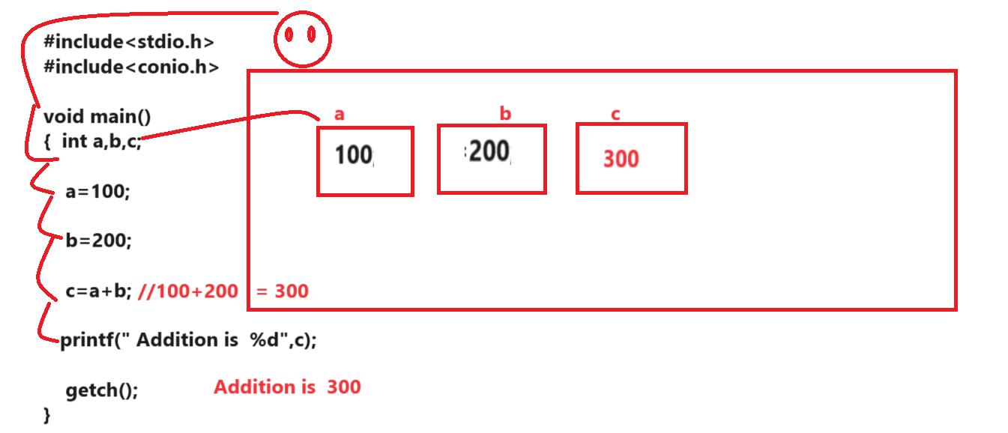
If we think about above diagram or code we calculate addition of two fix values but we want to accept the input from keyboard and after that calculate its addition

How to accept input value from keyboard after program run
______________________________________________________________________________
If we want to accept input value from keyboard after program run we have to use scanf() function
scanf() function is member of stdio.h header file

Syntax: scanf(“format specifier”,&variablename);

Example:
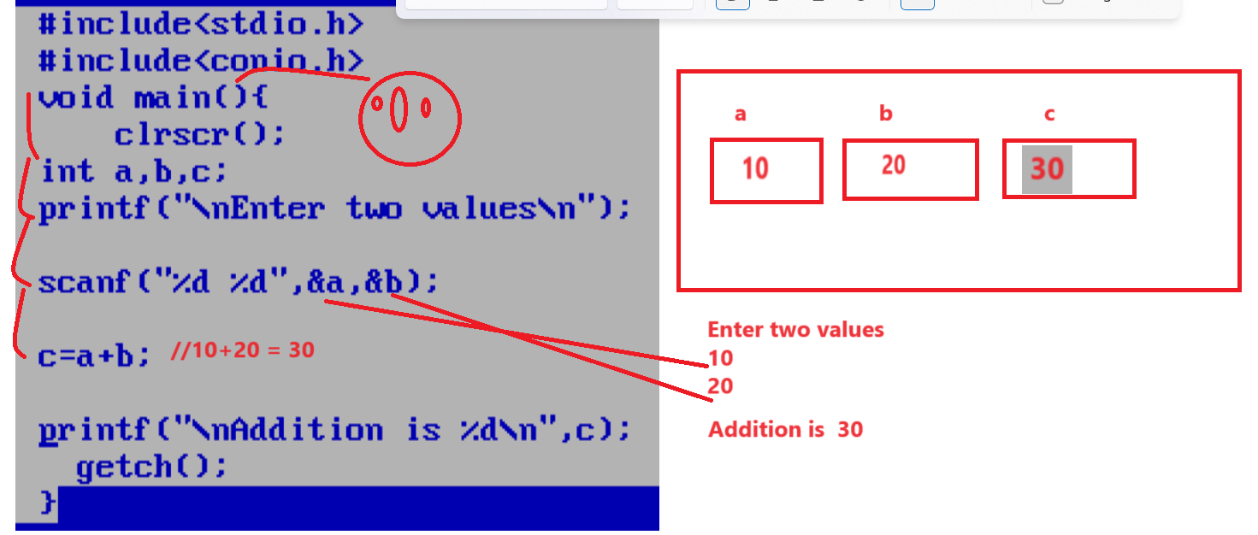

Example: WAP to input the radius of circle and calculate its area.
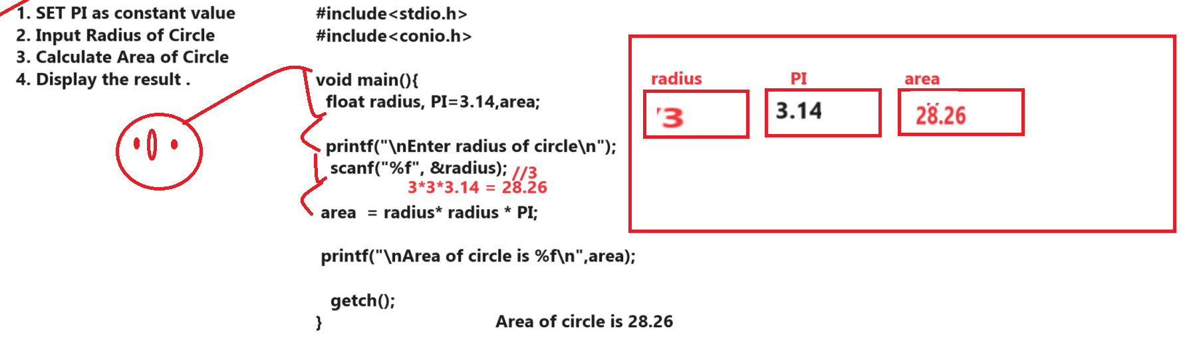

Example: WAP to input the basic salary of employee and calculate its total salary using following terms
da=30% of basic salary
hra=30% of basic salary

bs=1000
da=300
hra=300
total = bs+da+hra = 1000+300+300 = 1600
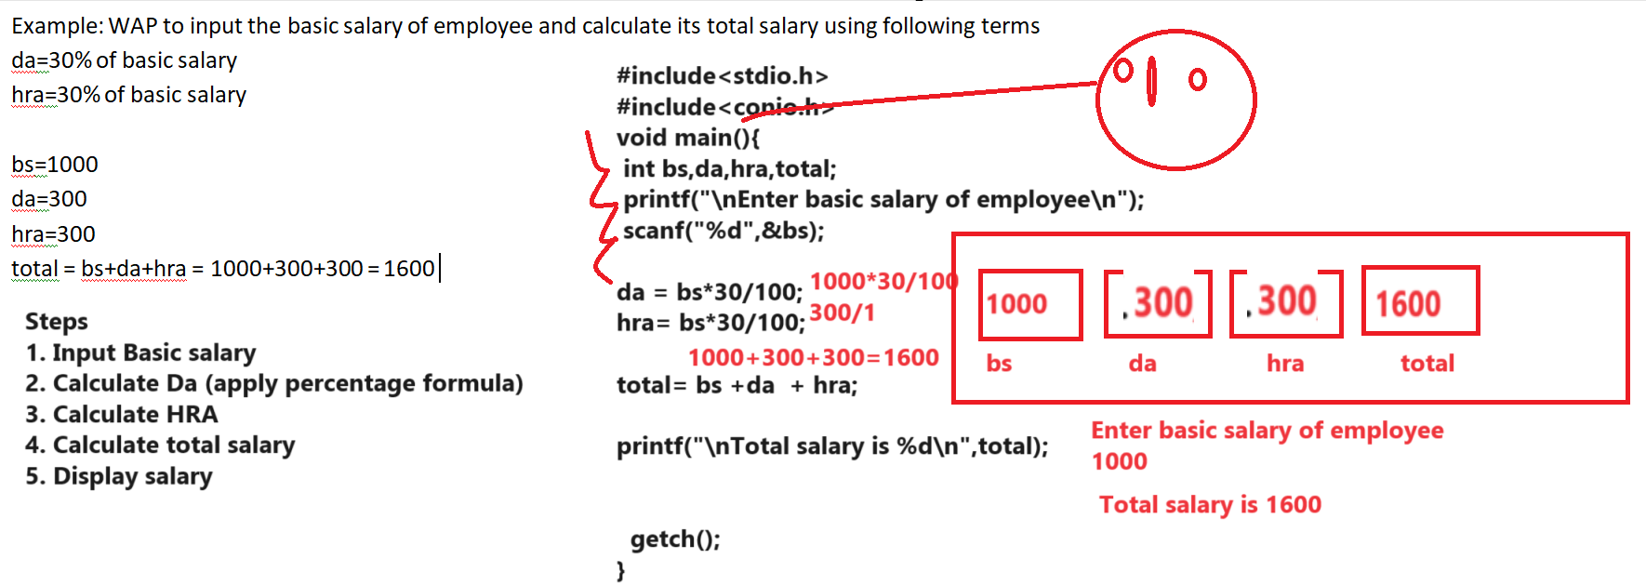

Example: WAP to input six subject marks of students and calculate its percentage and check student is fail or pass if percentage greater than 40 then student is pass otherwise student is fail so check condition by using conditional operator.

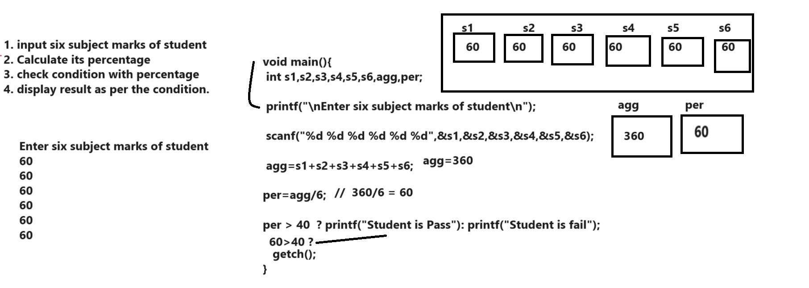

WAP to input the quantity and rate from keyboard and calculate its bill with 18% GST
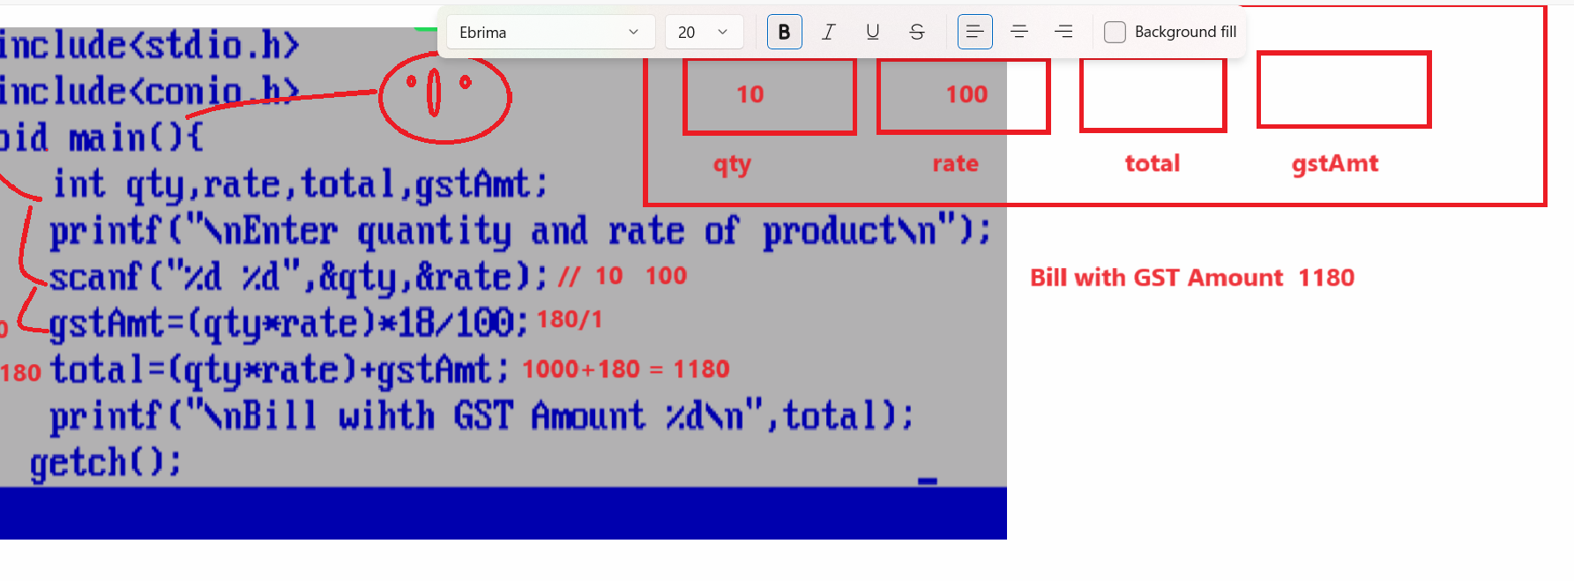

Q. WAP to input the selling price and cost price of item and find out seller made profit or loss.
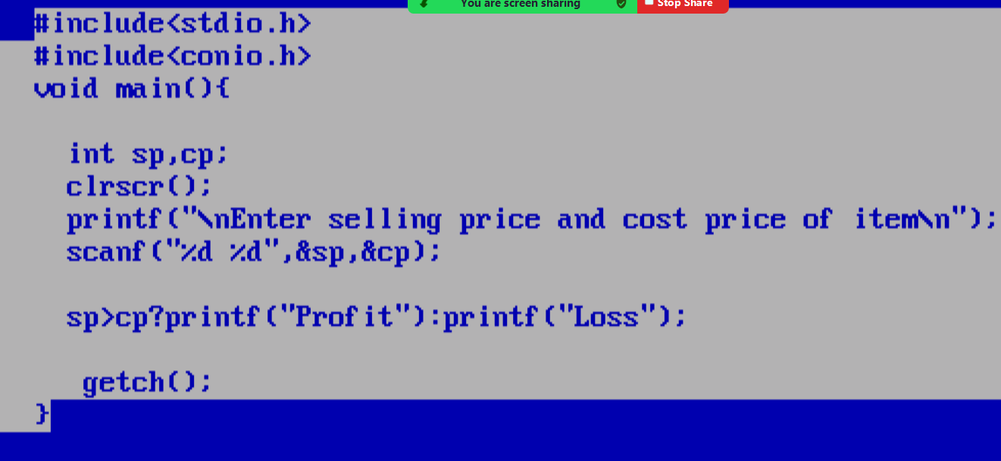

Q. WAP to input number and extract its last digit?
Input: 1234
Output: Last digit is 4.

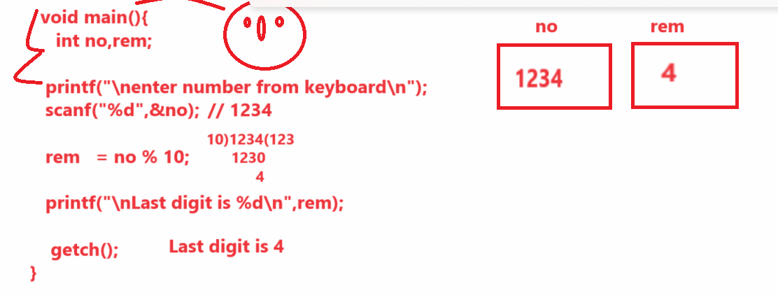
Example: WAP to input four digit numbers and extract first digit from number.
Input: 1234
Output: 1
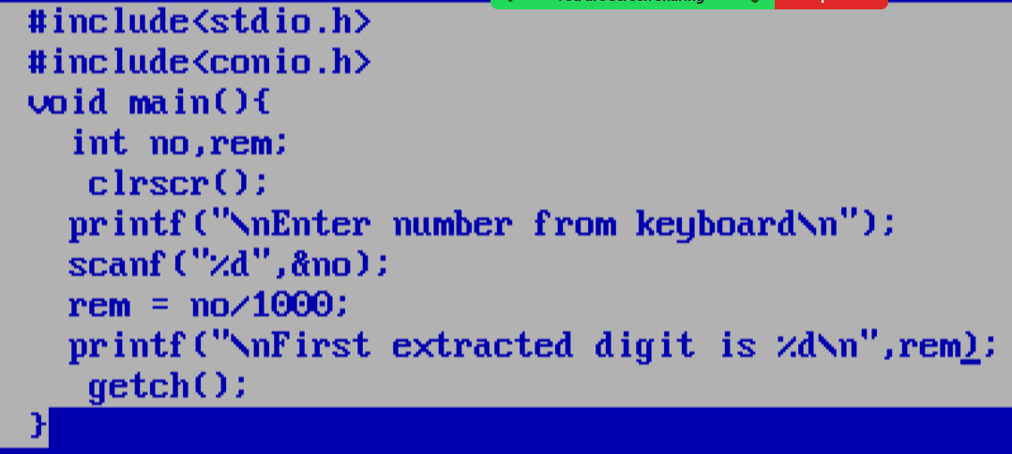

Example: WAP to input the three digit number and remove the last digit of number from it.
Input: 123
Output: 12

Bitwise operator
____________________________________________________________________________________
Bitwise operator is used for perform operation on bits but if we want to work with bitwise operator we need to know the number system and its conversion as well as we need to binary and operation on bits, binary or operation on bits, one’s complete and two’s complement etc we need to know.

Number System: Number System is technique where we can decide how number represent in memory called as number system.
There are four types of Number System
_________________________________________________________________________________
1. Binary number: Binary number system means we represent a number in 0 and 1 format in memory called as binary number and there are two digits present in binary number so the base of binary is 2. we can say base means it represents number of digit present in number system.

(10101010)
2 – base
2. Decimal Number: decimal number system means we represent a number between 0 to 9 called as decimal number system means there is total 10 digits present in decimal number system so the base of decimal number system is 10.

(123456789)
10 – base of decimal
3. Octal Number: Octal number system means those number contain value between 0 to 7 so the base of octal number system is 8.

(1234567)
8 – base of octal
4. Hexa Decimal number : Hexa decimal number system means value present between 0 to 15 and after 10 consider A, 11 B, 12 C, 13 D, 14 E 15F etc so the base of hexa decimal number system is 16

(123AF)
16– Base of Hexa decimal number system

If we want to work with bitwise operator we need to know conversion of number system
Means convert binary number to decimal or decimal to binary etc

How to convert decimal number in to binary number
_______________________________________________________________________________
If we want to convert any decimal number in to binary number we need to divide the number by 2 and calculate its reminder and pick all reminders from bottom to top
Example: Calculate the binary number of 5
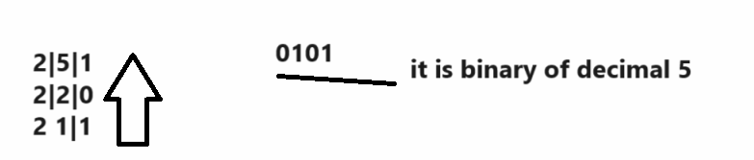
Example: Calculate the binary number of 14
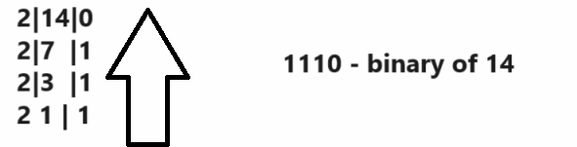
Example: Calculate the binary of 18
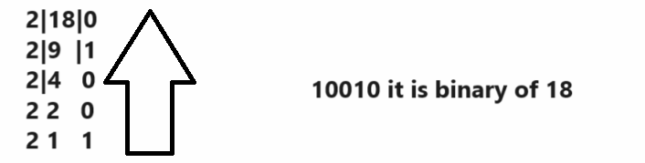

How to convert binary number in to decimal
___________________________________________________________________________
If we want to convert binary number in to decimal we need to multiply binary number by 2 and arrange power index from right to left and calculate its sum

Example: Calculate Decimal number of 0101
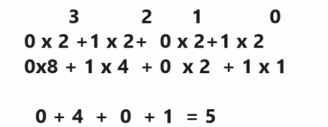

Example: find the decimal number of 0111
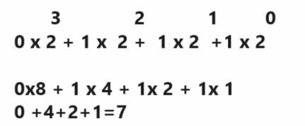

Example: Find the decimal of 1110
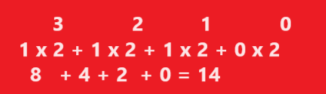

Binary OR Operation and Binary AND Operation
__________________________________________________________________
When we work with binary AND operation then if any value between two input is 0 then it is 0 otherwise 1

Binary AND Operation Chart
First | Second | Result
0 | 0 | 0
0 | 1 | 0
1 | 0 | 0
1 | 1 | 1

Binary OR operation
_____________________________________________________________________
First | Second | Result
0 | 0 | 0
0 | 1 | 1
1 | 0 | 1
1 | 1 | 1

One’s Complement operation
_________________________________________________________________________________
One’s complete means negative values in binary number system means convert 0 to 1 and 1 to 0

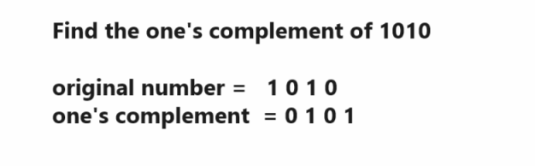

Two’s Complement operation
_______________________________________________________________________
Two’s complement means first find the one’s complement of number and add +1 in at right hand side of number
Example: find the 2’s complement of 0101
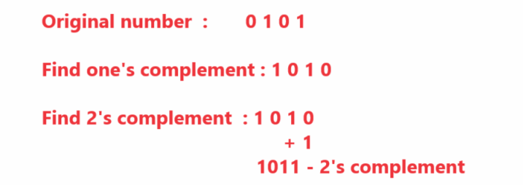

Bitwise operator chart
Operator | Meaning
| | Bitwise OR
& | Bitwise AND
<< | Left shift operator
>> | Right shift operator
~ | One’s complement
^ | XOR Operator

Binary | (OR) operator
___________________________________________________________________________
Binary OR operator convert decimal value in to binary number internally and perform binary OR operation on it and convert binary resultant binary number in to decimal.

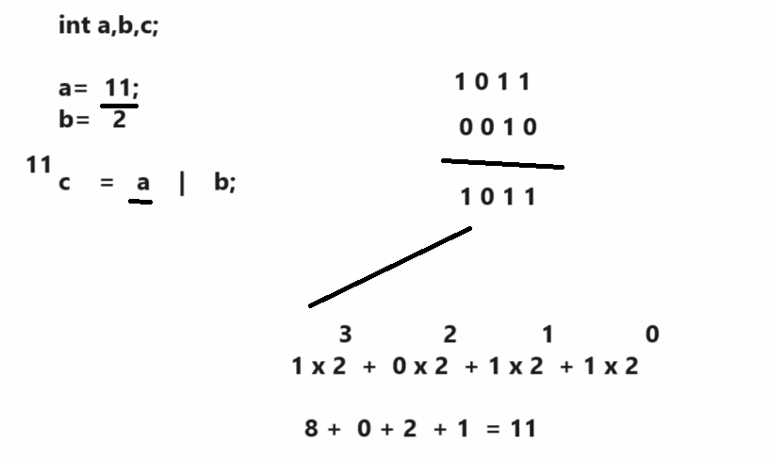

Example:
#include<stdio.h>

int main(){

int a=11,b=2,c;

c = a | b;
printf("\nC=%d\n",c);

return 0;
}
Q. what will be output of given code?
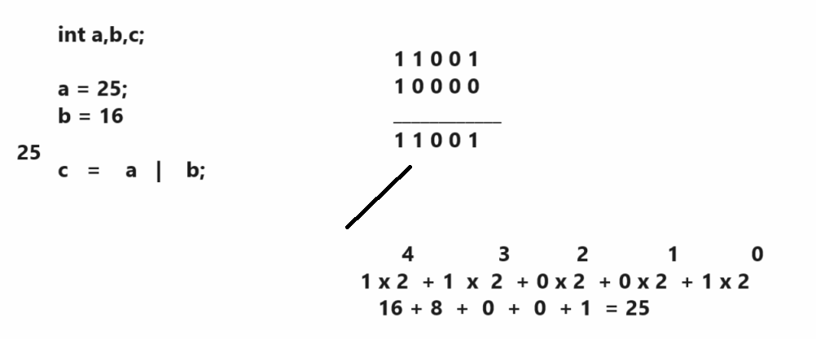

Bitwise AND Operation
________________________________________________________________
Bitwise AND operator convert decimal number in to binary and perform binary and operation on it and convert resultant value in to decimal and store at left hand side.
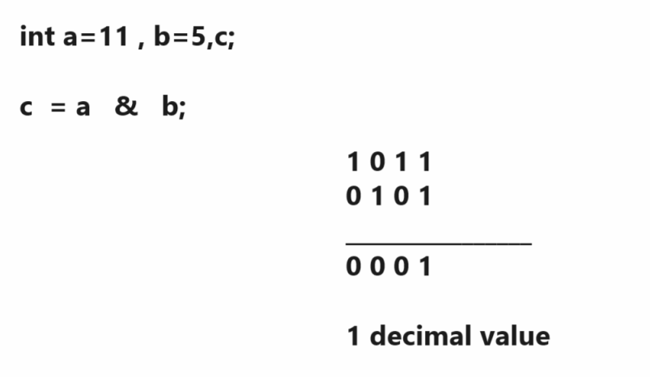
Source code
#include<stdio.h>
int main(){
int a=11,b=5,c;
c = a & b;
printf("\nC=%d\n",c);
return 0;
}
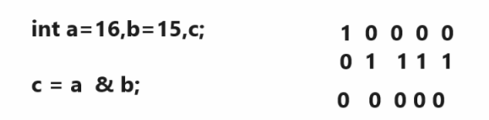
Left shift operator: left shift operator is used for shift the bits at left hand side 0’s at right hand side
Shown in following code.
Example:
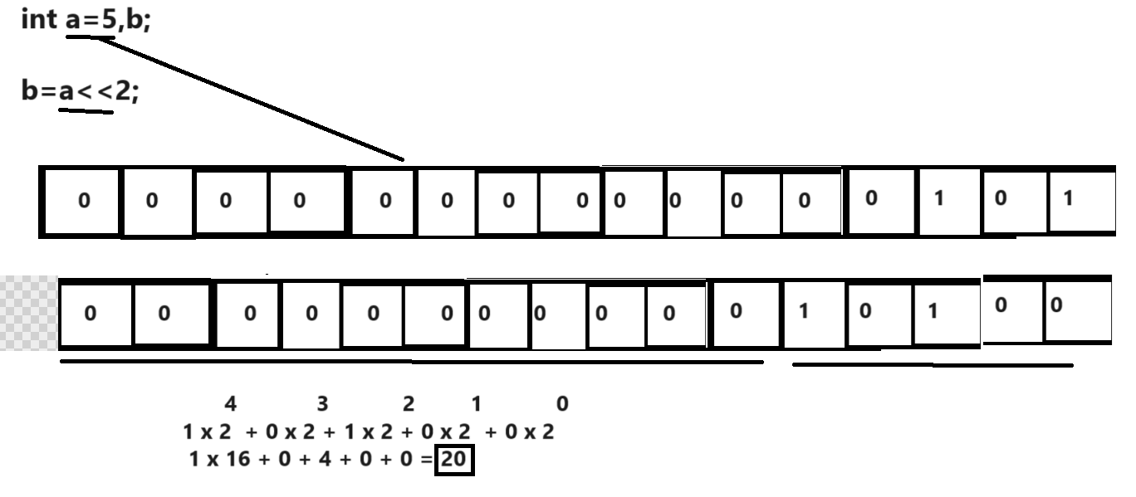

Right shift operator (>>): right shift operator is used for shift bit at right hand side and adds 0 at left hand side.
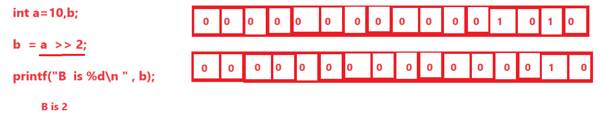

XOR Operator (^) : this operator help us to perform XOR operation with two binary digit and generate rules in XOR operation when we have two same value then result is 0 and if we have two different values then result is 1.
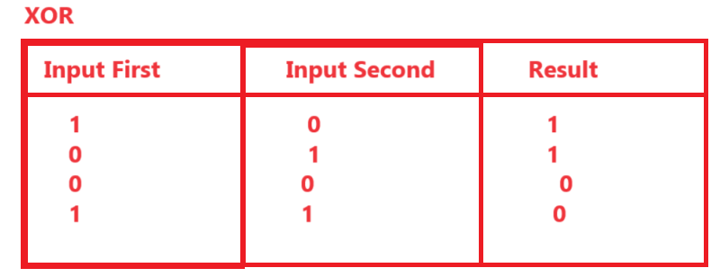
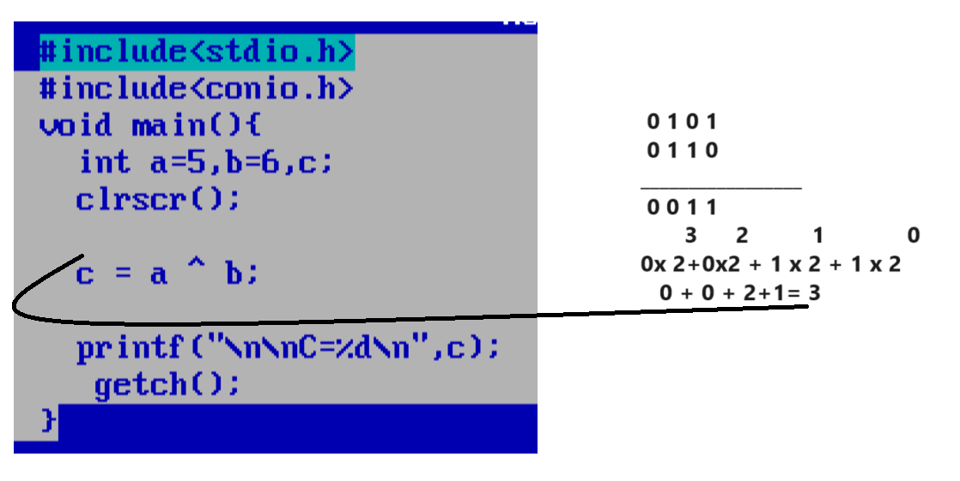

~(one’s complement operator): one’s complete operator is used for perform negation operation with binary values
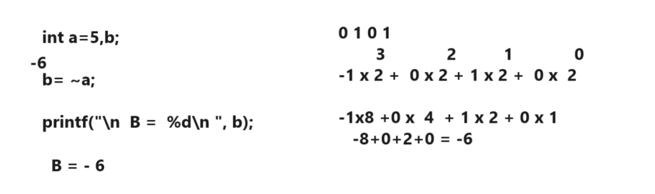

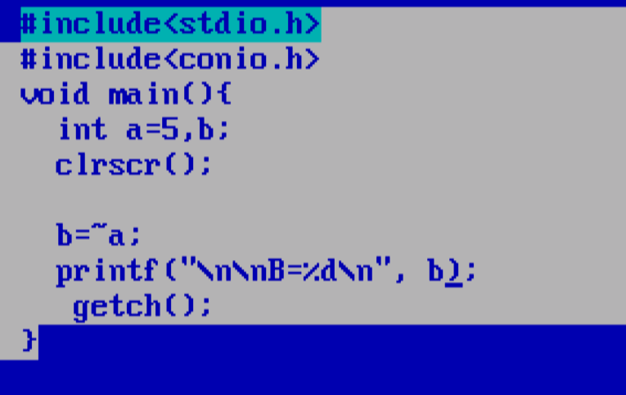

Precedence/Priority of operator In C Language
_________________________________________________________________________________
Precedence decide which operator execute when or decide the execution priority of operator in application

Precedence Number | Operator | Association
1 | ++, --(pre) ,(),[],. -> | Left to right
2 | - (unary) , & ,sizeof | Right to left
3 | * / % | Left to right
4 | + - | Left to right
5 | << >> | Left to right
6 | < <= > >= | Left to right
7 | == != | Left to right
8 | & | Left to right
9 | ^ | Left to right
10 | | | Left to right
11 | && | Left to right
12 | || | Left to right
13 | ? : | Right to left
14 | ++, -- (Post) | Left to right
15. | = , +=, -= , *=,etc | Right to left
16 | , | Left to right

Q.what will be output of given code?
